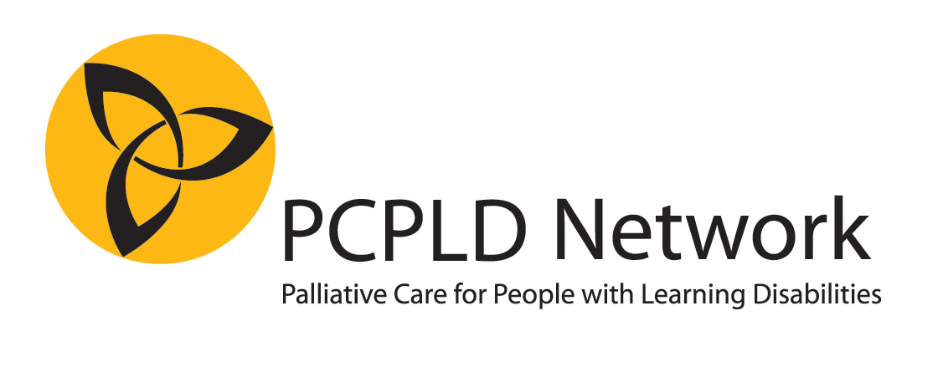
Nomination for the Linda McEnhill Award

Category B: Outstanding end of life support of an individual
Please complete all parts of this form and return by email to award@pcpld.org by 6th October 2017
Please do not send any additional documentation or attachments. Any attachments other than this form will NOT be seen or assessed by the judges. If shortlisted, we may ask you to provide additional documentation if relevant.

NOMINEE
Title / Name of team of nominated
Address

Telephone number
E mail

NOMINATOR (NB it is possible to nominate yourself, or your own team)
Name
Address

Telephone number
Email

Relationship to nominee

Please complete a statement of up to 1,500 words, explaining why you think this person/team should be given the award. It is recommended (but not obligatory) to use the guiding questions on the next page. (You may find that not all the questions are relevant, or you may want to tell us something different).
Please indicate whether or not names used are pseudonyms (if you are using people’s real name, we will treat this in confidence. We only publish names with if this has been agreed with the people involved, including families).

Please note that it is not possible to submit any additional documentation. Any attachments other than the statement will NOT be seen or assessed by the judges.

About the person: Describe the person with learning disabilities (it is helpful for us if you can “paint a picture” of the person and the life they lived when they were well)

The person’s illness: Tell us something about how the illness started, the diagnosis, early treatments, and how the illness progressed.

Who was involved? At the time of diagnosis, and later, as the illness progressed (you may prefer to tell us about this whilst describing the illness itself – but make sure we know which professionals, carers, family members, friends etc where involved)

Care Planning: Tell us about the person’s physical, psychosocial and spiritual needs, and how these were addressed

The end of life: Tell us about the person’s dying and death, their funeral, or anything else you wish to say about the time around and immediately after the death.

After the death: What was the person’s legacy? How do those who supported the person look back on the experience? What have they learned?

Please send the completed form and any queries to award@pcpld.org.

