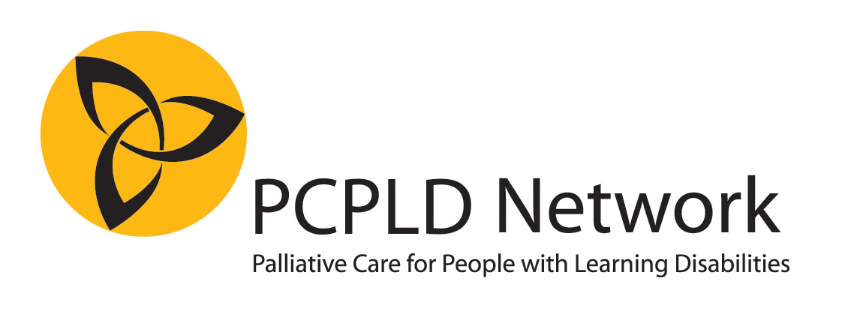
Nomination for the Linda McEnhill Award
Office use only: Number:
Cat A

Category A: A new development or innovation in care / excellence in overall end of life support for people with learning disabilities

Please complete all parts of this form and return by email to award@pcpld.org by 6th October 2017
Please do not send any additional documentation or attachments. Any attachments other than this form will NOT be seen or assessed by the judges. If shortlisted, we may ask you to provide additional documentation if relevant.

NOMINEE
Title / Name of person or team of nominated:
Address:
Telephone number:
E mail:
NOMINATOR (NB it is possible to nominate yourself, or your own team)
Name:
Address:
Telephone number:
Email:
Relationship to nominee:
Please complete a statement of up to 1,500 words, explaining why you think this person/team should be given the award. It is recommended (but not obligatory) to use the guiding questions below. (You may find that not all the questions are relevant, or you may want to tell us something different).
Please indicate whether or not names used are pseudonyms (if you are using people’s real name, we will treat this in confidence. We only publish names with if this has been agreed with the people involved, including families).

Do you have any additional documentation that might be of interest to the judges?
(we may ask you to provide this if you are shortlisted) YES/NO

Evidence of excellence in end of life care for people with learning disability: Tell us why you think this work demonstrates excellence.

Benefits for people with learning disabilities at the end of life: Who has benefited or will benefit from this work?

Evaluation of the development/initiative/work: What is the evidence that this is an excellent development? Has there been any evaluation of the work?

Innovation in care: Is this work innovative? Why/how?

Impact of the initiative: Describe the impact of this work (for example, on people with learning disabilities, staff, carers, families….)

And finally… In a nutshell, why do you think this person/team deserves the award? (You could also describe what you think others could learn from this nomination, if it won the award)

Thank you, please return this form to award@pcpld.org Please contact us if you have not received confirmation of receipt within 7 days.

